Ideation Phase
Brainstorm & Idea Prioritization
Date | 04 September 2026
Student Name | Pulibanti Tejavani
Project Name | Metro Ticket Generating System
Maximum Marks
Brainstorm & Idea Prioritization
The brainstorming process focuses on developing a convenient digital metro ticketing solution using ServiceNow. The proposed ideas cover ticket booking, station selection, automated fare calculation, digital QR-ticket generation, portal usability, security, and future system enhancements..
Idea Group | Priority
Metro ticket booking service | High
Station and destination management | High
Automatic fare calculation | High
Digital QR ticket generation | High
Service Portal interface | High
Payment mode handling | High
Automated workflow | Medium
Access control and security | Medium
Future analytics and notifications | Low

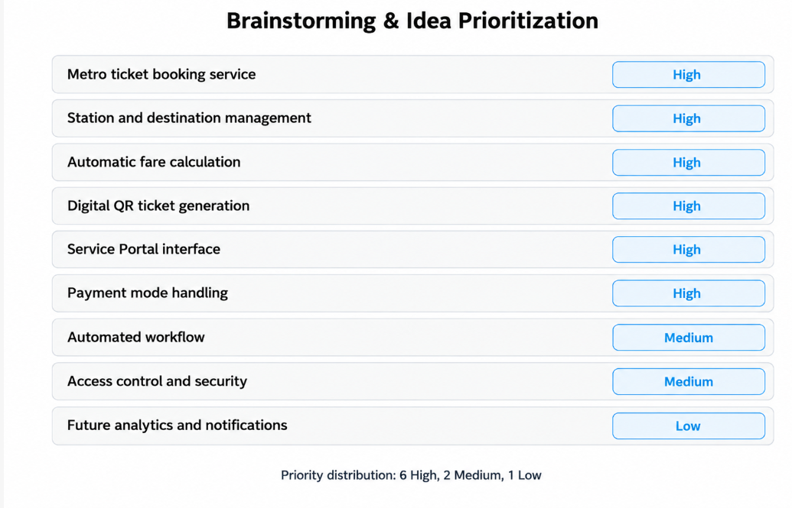

Figure 1: Prioritized brainstorm representation based on the project ideas.

